Chronic Kidney Disease Prediction using Machine Learning

Mattepally Siri Chandana

Kakkerla Pavani

Kodipaka Saathvik

Katakam Avinash

Dept of CSE

SR University

Abstract— Chronic Kidney Disease (CKD) is a long-term condition marked by a steady decline in kidney function, significantly impacting global health and economies. It affects about 10 per of the population, contributing to high mortality rates and substantial financial burdens, particularly in underserved areas with limited access to dialysis and transplants. This study leverages machine learning techniques, including Random Forest, Decision Tree, KNN, XGBoost, and AdaBoost, for CKD prediction. Random Forest exhibited unparalleled performance with 100per accuracy, underscoring its potential in advancing early CKD detection and improving management strategies through precise predictions.

Keywords: Chronic Kidney Disease, KNN, Decision tree, Random forest, Xgboost, AdaBoost, Machine Learning

# I. INTRODUCTION

” Chronic Kidney Disease (CKD) is characterized by means of a gradual decline in kidney feature over an extended length. As kidney feature deteriorates, a patient may additionally revel in worsening persistent renal disease, leading to a decline of their normal pleasant of life. approximately 10 per of the global populace is affected by CKD. via 2040, it is anticipated to turn out to be the 6th maximum not unusual motive of death international, contributing significantly to excessive scientific expenses. In excessive-earnings countries, charges for dialysis and transplants can account for 2/3 per of the national clinical price range. In low and middle-profits international locations, many kidney failure sufferers lack get right of entry to to kidney transplants and existence-saving dialysis.excessive blood strain and diabetes are primary reasons of CKD. global researchers diagnose CKD the usage of markers of kidney harm and the Glomerular Filtration rate, a circumstance that steadily impairs kidney characteristic. individuals with CKD are at a higher risk of premature demise. To prevent CKD, docs must directly perceive various conditions associated with it. CKD can worsen due to numerous danger factors, which includes diabetes, genetic predispositions, high blood pressure, coronary artery sickness, urge for food changes, pedal edema, and anemia. Its signs and symptoms, regularly moderate initially, get worse because the disorder progresses. In 2020, globally, 467 million women and 392 million guys had been suffering from persistent renal illness. In 1990, CKD prompted 409,000 deaths; by way of 2015, the range of deaths had risen to 1.2 million. excessive blood strain is the main reason of dying (550,000 deaths), followed by means of diabetes (418,000 deaths) and glomerulonephritis (238,000 deaths). however, extensive advances in the understanding of renal illnesses were made in the nineteenth century, with British health practitioner Richard vivid pioneering studies into what’s now referred to as vibrant’s sickness. within the 20th century, in addition advancements included the creation of diagnostic gear to measure blood ranges of urea and creatinine. The term “CKD” first regarded in the 1970s and Eighties, characterizing long-time period kidney damage and lack of feature.

A. Tiers of CKD

An indicator of ways efficiently the kidneys are functioning the eGFR, is used to classify CKD into five levels. Healthcare companies can examine the volume of kidney damage and pick out the high-quality route of treatment via the usage of the phases of CKD. The levels are:

1. normal CKD: At this early level, renal impairmentis obvious, but the eGFR stays inside the regular variety. even though kidney function may be extremely decreased, maximum individuals do not exhibit important signs and symptoms.
2. mild CKD: This degree involves a mild discount inkidney characteristic and a moderate decline in eGFR. much like stage 1, renal impairment is obvious, but symptoms might not be excessive.
3. moderate CKD: Kidney characteristic is moderatelyimpaired, and people may additionally begin to experience fatigue, swelling, and modifications in their urine. This degree is similarly divided into level 3a (eGFR 45-59 mL/min/1.seventy three m²) and level 3b (eGFR 30-forty four mL/min/1.73 m²).
4. excessive CKD: At this stage, kidney characteristic isconsiderably impaired, and symptoms are in all likelihood to be extra stated. remedy frequently consists of careful control of signs and symptoms and instruction for renal substitute remedy, inclusive of dialysis or kidney transplantation.
5. cease-stage CKD: this is the most superior stage ofCKD, with appreciably decreased kidney characteristic and an exceptionally low eGFR. At this point, renal substitute therapy is frequently required to preserve lifestylesmaintaining functions. remedy options consist of dialysis and kidney transplantation

”

## II. LITERATURE REVIEW

” chronic Kidney disease (CKD) prediction has been a focus of wonderful research, with system mastering strategies proving instrumental in improving early detection and evaluation. The 2020 IEEE global conference for Innovation in technology (INOCON) explored the implementation of algorithms like desire trees and SVM, emphasizing how robust preprocessing and feature choice are vital for reinforcing predictive accuracy. further, V. Srikanth’s study in contrast strategies which incorporates logistic regression and Random woodland, finding ensemble models especially effective for coping with imbalanced datasets and offering dependable predictions. The EAI endorsed Transactions article carried out a complete evaluation of CKD detection, advocating hybrid models for their superior sensitivity and specificity. Optimization techniques had been highlighted inside the 2020 iSAI-NLP symposium, which confirmed how hyperparameter tuning and feature engineering considerably lessen errors charges in fashions like Neural Networks and Gradient Boosted Machines. The studies published in IJARCCE explored Na¨ıve Bayes and choice timber, underlining the significance of data preprocessing strategies at the side of normalization to enhance algorithmic ordinary performance. The IEEE look at on risk prediction of CKD bolstered the value of scientific parameters like serum creatinine in enhancing version effects, with Random wooded vicinity and Gradient Boosting showing immoderate predictive electricity. superior techniques, which includes explainable AI and Deep studying, were featured inside the magazine of large statistics, wherein the emphasis modified into on integrating interpretable fashions with medical workflows for better usability. An empirical evaluation in IEEE get proper of access to in evaluation numerous algorithms like SVM and Deep Neural Networks, advocating ensemble strategies to stability computational efficiency with immoderate accuracy. Weilun Wang and co-people improved on this by way of incorporating demographic and medical functions into ensemble models, enhancing early chance stratification. eventually, the IJCSIS take a look at focused on linear and non-linear classifiers, highlighting how dimensionality cut price techniques can growth prediction reliability

”

## III. METHODOLOGY

### A. Dataset

The kidney disease dataset is a established series of four hundred affected person records,consisting of 26 capabilities that embody demographic,scientific, and laboratory information.it is tailored for constructing predictive models to perceive chronic kidney disorder (CKD).The dataset comprises numerical variables consisting of age,blood stress,and serum creatinine tiers,alongside categorical attributes like the presence of diabetes,high blood pressure,and anemia. The target column, ”classification,” shows whether or not a patient has CKD or no longer. earlier than using the dataset for system studying, preprocessing steps are crucial,which include addressing missing values,normalizing numerical facts,and encoding categorical capabilities.visible equipment like histograms, box plots, and correlation heatmaps can offer insights into statistics styles and relationships. The dataset may be divided into education and testing subsets(usually in an eighty:20 ratio)to develop predictive fashions such as Random woodland,selection timber,or help Vector Machines.strategies like function significance evaluation can spotlight essential factors influencing CKD predictions, even as metrics like accuracy and recall validate the model’s effectiveness.moreover,interpretability tools along with SHAP can offer deeper insights into the effect of individual capabilities,making this dataset a robust useful resource for advancing early CKD detection and control.

### B. Data processing

”It starts offevolved with dealing with missing data, in which numerical capabilities with missing values may be imputed the usage of the mean or median, at the same time as specific functions can be full of the most commonplace class. subsequent, numerical records which includes blood strain and creatinine levels are normalized to make sure that all functions have the same scale, preventing any one function from dominating. specific variables like the presence of hypertension or diabetes are transformed into numerical values using techniques like label encoding or one-warm encoding. Outliers are diagnosed and handled appropriately to save you distortion in version schooling. The information is then split into training and checking out subsets, commonly in an eighty:20 ratio, to allow for powerful model training and evaluation. extra steps like function scaling and standardization is probably applied depending at the version used. by means of following those preprocessing steps, the dataset will become extra based and ready for accurate system mastering predictions.

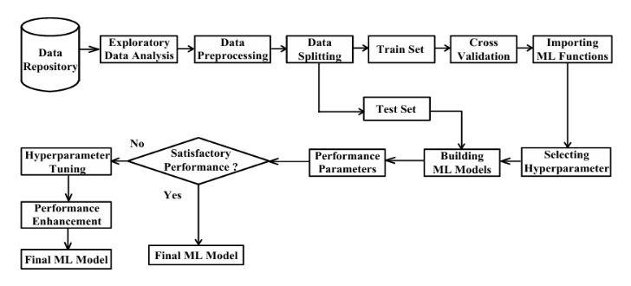

## IV. METHODS USED

” system literacy(ML),a fleetly evolving subject within artificial intelligence,entails creating fashions and algorithms that allow computer systems to become aware of styles in information,draw conclusions,and make prognostications with out unequivocal programming.The center theory of ML is allowing systems to analyze from once gests and ameliorate over the years. colourful ML algorithms are used for CKD discovery

* k- Nearest Neighbours(KNN) is used for both retrogression and bracket but is drastically implemented to bracket problems.it’s anon-parametric set of rules that learns by using comparing new facts with the complete dataset grounded on Euclidean distance.the selection of k value is pivotal for delicacy.
* Random wooded area This ensemble literacy machine generates a couple of choice timber and summations their outcomes.It handles both bracket and retrogression obligations,enhancing delicacy and precluding overfitting via methods like bagging.
* selection Tree A selection tree fashions evaluations in a tree- suchlike structure wherein bumps represent features,branches constitute choice policies,and leaves represent problems.It parts statistics grounded on critical attributes,abetting in each bracket and retrogression obligations with its simplicity and interpretability.
* AdaBoost Classifier AdaBoost combines several vulnerable classifiers to supply a robust bonevia emphasizing the crimes of each classifier in consecutive rounds.This iterative method improves delicacy,specially beneficial for double bracket tasks.
* XGBoost XGBoost is an powerful grade boosting machine that builds sturdy models through adding weak rookies,normally choice bushes,and applying regularization approaches to help overfitting.it’s known for its speed and effectiveness in managing massive datasets.

## V. RESULT AND COMPARISON

Some of the various models evaluated for continual kidney ailment(CKD)kind,the Random wooded region Classifier could be the maximum correct,reaching an first-rate test accuracy of 1.0.This version demonstrates amazing usual performance, with precision, do not forget,and F1-rankings all same to 1.0 for every CKD and non-CKD education, indicating perfect predictions. The AdaBoost Classifier carefully follows with a take a look at accuracy of 0.9917,showing excellent category results and excessive precision and keep in mind for each training,much like the Random wooded area model. The XGBoost model also achieves a check accuracy of 0.9917,imparting similar results to both AdaBoost and Random woodland,and is considered another pinnacle-performing version.the selection Tree Classifier,whilst nonetheless effective,achieves a barely lower accuracy of 0.96 and shows proper however no longer terrific precision and consider for each schooling.ultimately, the okay-Nearest Neighbours(KNN)classifier yields the lowest overall performance,with a take a look at accuracy of 0.65 and much less particular class outcomes,specifically for CKD times.everyday,the Random wooded area Classifier is the pleasant acting model in this venture,followed cautiously via AdaBoost and XGBoost.the selection Tree and KNN models,though beneficial,do not perform as well in evaluation.

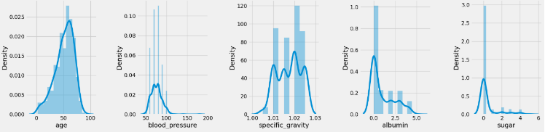

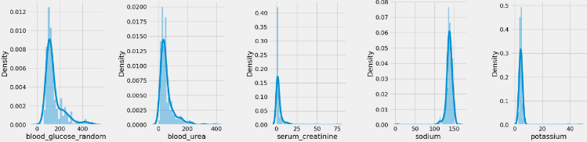

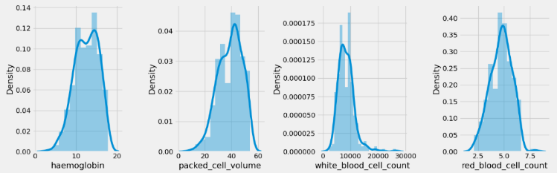

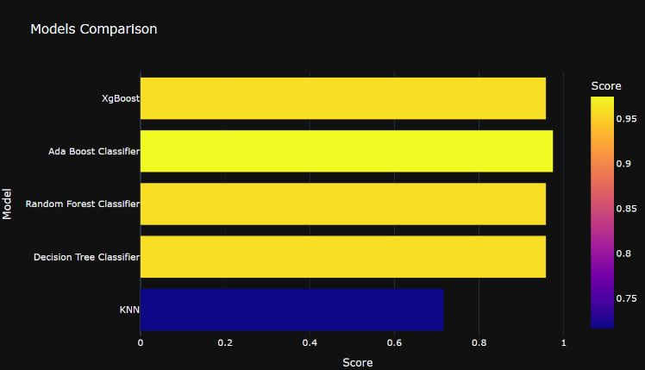

## VI. CONCLUSIONS

” In precis, a thorough evaluation of numerous methodologies and advancements in the observe of chronic kidney ailment (CKD) has emerged from the evaluation of numerous research works in this area. Researchers have explored various factors of CKD, including early diagnosis and detection, remedy strategies, and predictive modeling. A sizable consciousness in modern-day CKD studies lies within the integration of scientific data and medical imaging with the usage of machine learning strategies. those collective insights highlight the complexity of CKD and emphasize the continued need to beautify our information and control of this essential public health task.

”

# REFERENCES

1. Implementation of machine learning algorithms to assess the diagnosis rates of kidney disease. Presented at the 2020 IEEE International Conference for Innovation in Technology (INOCON), Bengaluru, India, November 6-8, 2020.
2. Srikanth, V. (2020). Prediction of chronic kidney disease using machine learning algorithms. Research conducted in the domains of MCA, M.Tech, MBA, and PGDBM.
3. Nishat, M.M., Faisal, F., Dip, R.R., Nasrullah, S.M., Ahsan, R., Shikder, F., Raihan Asif, Md. A., & Hoque, Md. A. (2022).
4. Optimization of predictive methods for chronic kidney disease utilizing machine learning algorithms. Presented at the 2020 15th International Joint Symposium on Artificial Intelligence and Natural Language Processing (iSAI-NLP).
5. Risk prediction of chronic kidney disease using machine learning techniques. IEEE Publication No. 49239.
6. Debal, S., & Sitote, A. (2022). Chronic kidney disease prediction through machine learning methodologies. Published in the Journal of Big Data. DOI: 10.1186/s40537-022-00657-5.
7. Khan, B., Naseem, R., Muhammad, F., Abbas, G., & Kim, S. (2022). Empirical analysis of machine learning techniques for chronic kidney disease prediction. IEEE.
8. Qezelbash-Chamak, J., Badamchizadeh, S., Eshghi, K., & Asadi, Y. (2022). A review of machine learning approaches in kidney disease analysis.
9. Colli, V.A., Gonzalez-Rocha, A., Canales, D., Hernandez-Alcazar, C., Pedroza, A., Perez-Chan, M., & Simon, S. (2022). Evaluation and enhancement of chronic kidney disease risk prediction scores in the Mexican adult population.
10. Chittora, P., Chaurasia, S., Chakrabarti, P., Kumawat, G., Chakrabarti, T., Leonowicz, Z., Jasinski, M., Gono, R., Jasińska, Ł., & Bolshev, V. (2021). Machine learning-based prediction of chronic kidney disease. Published in IEEE Access. DOI: 10.1109/ACCESS.2021.3053763.
11. Machine Learning Techniques for Chronic Kidney Disease Risk Prediction”,Published in Big Data and Cognitive Computing, 2022.
12. Boosting Techniques for CKD Prediction Published in PLOS ONE, 2022. This paper explores ensemble learning models like AdaBoost and Gradient Boosting for CKD detection.
13. Ensemble Learning Approach for CKD Prediction Published in AI and Medical Informatics, 2022. This research evaluates models including Random Forest and Support Vector Machines for disease risk evaluation
14. Improved CKD Diagnosis Using ML Algorithms Published in IEEE Transactions on Healthcare Informatics, 2022.
15. Deep-Kidney: An Effective Deep Learning Framework for CKD Detection (2022) This paper proposed predictive models for early CKD detection using deep learning methods. Published in Springer Nature.
16. Chen, Fangyue et al. (2022) Prediction and Diagnosis of CKD Development and Progression Using Machine Learning Published in PLOS ONE.
17. Keerthana, L., et al. (2022) Prediction of Chronic Kidney Disease Using ML Techniques Published in International Journal of Advanced Research in Computer and Communication Engineering.